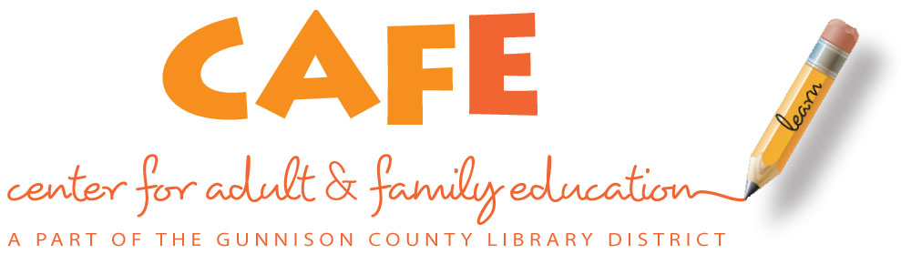

**Adult Education**

**Spring Term - 2016**

**Class Schedule**

*EVENING CLASSES*

ESL (English as a Second Language) Monday & Wednesday, 6-8 p.m.

Gunnison Elementary School January 11 – May 11

1099 N. 11th Street, Gunnison *Includes children’s classes (ages 0-13)*

**First day of class-** January 11

*MORNING CLASSES*

ESL (English as a Second Language) Tuesday & Thursday, 9:0-11:00 a.m.

Family Services Center January 12 – May 12

(Multicultural Resource Services Office) **First day of class-** January 12

225 N. Pine Street, Gunnison

***$25 Registration fee due at first class. Fee includes student workbook. $15 Registration fee for returning students.***

**No Classes**

Evening January 18, February 15, March 21 & 23

Morning February 16, March 22 & 24

Last day of class May 12 (morning), May 11 (evening)

**Call (970) 641-7684 for more information.**

*Se habla español.*